**Calculator Assumed**

**Applications of Differentiation 2**

Time: 45 minutes

Total Marks: 45

Your Score: / 45



**Question One: [6 marks] CA**

The function  is defined by the properties given below. Draw a sketch of this function on the axes provided.

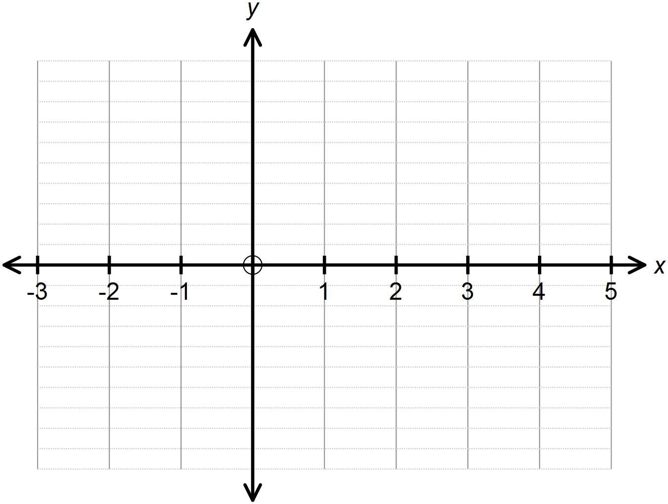

**Question Two: [2, 2, 2, 2, 2, 3 =13 marks] CA**

A financial institution is offering investors a return of 6% per annum to invest their savings in a term deposit over a period of 5 years.

An investor deposits $10 000 into this savings account.

1. Calculate the total value of the investment if the interest is compounded monthly.
2. Calculate the total value of the investment if the interest is compounded daily.
3. Calculate the total value of the investment if the interest is compounded continuously.
4. Using your answer to (c) or otherwise, determine a function that could model the growth of the investment if the interest is compounded continuously, where *t* is in years.
5. Calculate the instantaneous rate of growth of the investment after 4 years if the interest is compounded continuously.
6. Using the incremental formula, approximate the change in the investment from the 160th to the 161st day, if we assume the interest is compounded continuously and the year contains 365 days.

**Question Three: [2, 4, 6 = 12 marks] CA**

A lifeguard at Bondi sees a distressed swimmer 800 m out at sea.

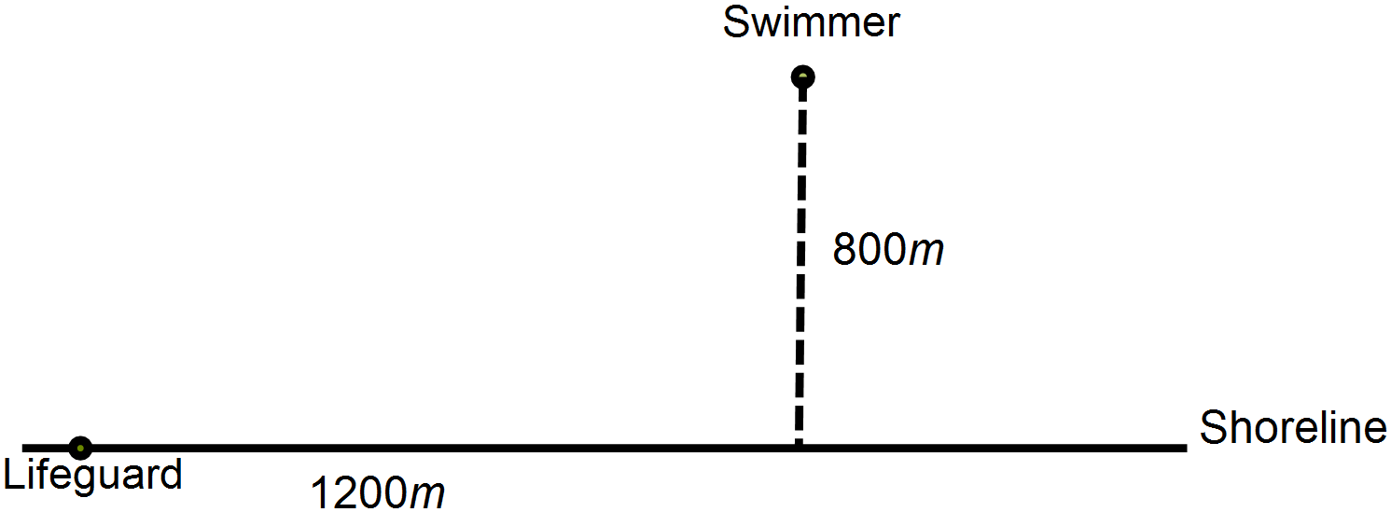

This lifeguard can run at a speed of 8km/h on sand and he can swim at a speed of 4km/h in the ocean. He will run some distance, *x* km, along the 1200 m shoreline and then swim out to the swimmer. He wants to get to the swimmer in the minimum time possible.

1. Add this information to the diagram above to illustrate the path of the lifeguard.
2. Determine a function  that models this situation where *T* is the time in hours and *x* is the distance the lifeguard will run along the beach.
3. By calculating the first derivative of , determine how far along the shoreline the lifeguard should run to minimise the time it takes him to get to the swimmer. State the time it will take him.

**Question Four: [1, 2, 2, 4, 5 = 14 marks] CA**

Rectangle WXYZ has WX = 4 cm and XY = 3 cm.

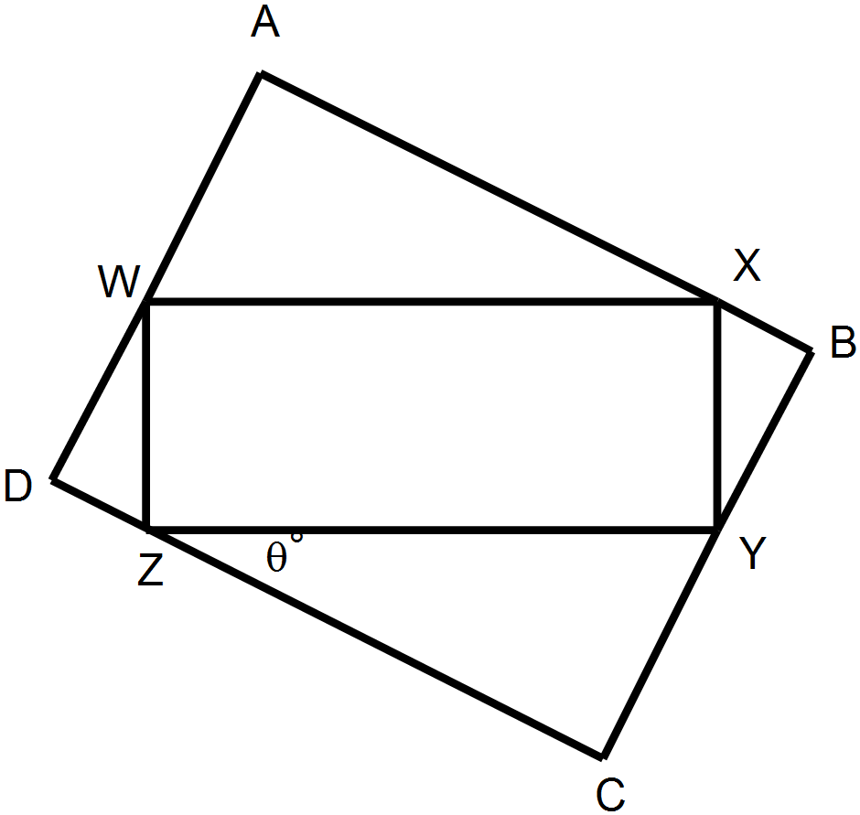A larger rectangle, ABCD, is circumscribed around WXYZ.

1. Show that 
2. Express length CY in terms of θ
3. Explain why 
4. Show that the area of rectangle ABCD can be given by 
5. Use calculus methods to determine the maximum area of rectangle ABCD.

**SOLUTIONS**

**Calculator Assumed**

**Applications of Differentiation**

Time: 45 minutes

Total Marks: 45

Your Score: / 45



**Question One: [6 marks] CA**

The function  is defined by the properties given below. Draw a sketch of this function on the axes provided.

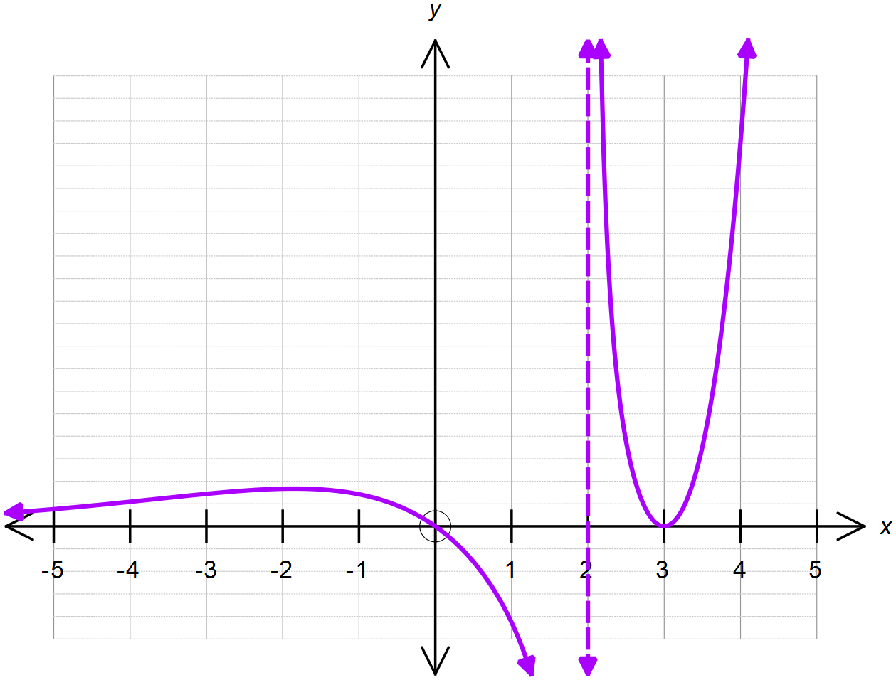

**Question Two: [2, 2, 2, 2, 2, 3 =13 marks] CA**

A financial institution is offering investors a return of 6% per annum to invest their savings in a term deposit over a period of 5 years.

An investor deposits $10 000 into this savings account.

1. Calculate the total value of the investment if the interest is compounded monthly.



1. Calculate the total value of the investment if the interest is compounded daily.



1. Calculate the total value of the investment if the interest is compounded continuously.



1. Using your answer to (c) or otherwise, determine a function that could model the growth of the investment if the interest is compounded continuously, where *t* is in years.



1. Calculate the instantaneous rate of growth of the investment after 4 years if the interest is compounded continuously.



1. Using the incremental formula, approximate the change in the investment from the 160th to the 161st day, if we assume the interest is compounded continuously and the year contains 365 days.



**Question Three: [2, 4, 6 = 12 marks] CA**

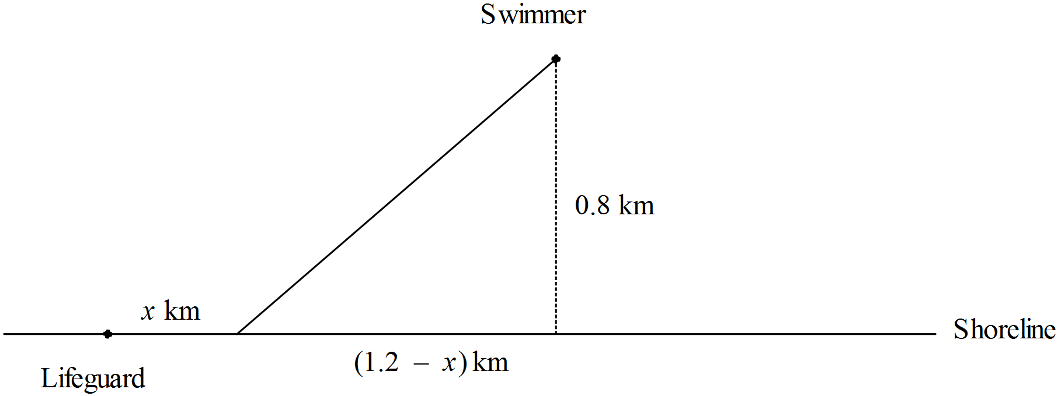A lifeguard at Bondi sees a distressed swimmer 800 m out at sea.







This lifeguard can run at a speed of 8km/h on sand and he can swim at a speed of 4km/h in the ocean. He will run some distance, *x* km, along the 1200 m shoreline and then swim out to the swimmer. He wants to get to the swimmer in the minimum time possible.

1. Add this information to the diagram above to illustrate the path of the lifeguard.
2. Determine a function  that models this situation where *T* is the time in hours and *x* is the distance the lifeguard will run along the beach.





1. By calculating the first derivative of , determine how far along the shoreline the lifeguard should run to minimise the time it takes him to get to the swimmer. State the time it will take him.



**Question Four: [1, 2, 2, 4, 5 = 14 marks] CA**

Rectangle WXYZ has WX = 4 cm and XY = 3 cm.

A larger rectangle, ABCD, is circumscribed around WXYZ.

1. Show that 



1. Express length CY in terms of θ



1. Explain why 



1. Show that the area of rectangle ABCD can be given by 



1. Use calculus methods to determine the maximum area of rectangle ABCD.

